
Richard Bangs’ Adventures with Purpose
Switzerland: Quest for the Sublime

Photos and Captions:
High resolution JPG files of these and other photos may be downloaded from the press section of www.AdventuresWithPurpose.tv. Photo files and captions are also on the enclosed press kit CD-ROM.

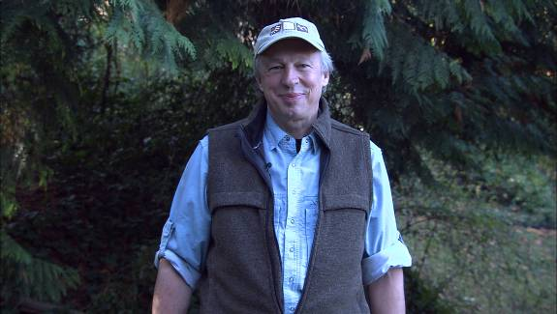
Richard Bangs hikes the Swiss Trail along the edge of Lake Lucerne. His one hour Adventures with Purpose documentary special, “Switzerland: Quest for the Sublime,” follows Bangs on a quest to discover the roots of adventure travel as he searches for what philosophers and poets of earlier times called “the sublime.” He begins in Lucerne—the gateway to the Alps—stops at Mt. Pilatus and Entlebuch Valley, travels on to world-renown St. Moritz then boards the famous Glacier Express train. Bangs side-trips to the Jungfrau region, and finally lands in Zermatt to experience the rapture of a deadly mountain that helped change our perception of nature—the Matterhorn. Richard Bangs is often called the father of modern adventure travel. Leader of 35 first descents of rivers around the globe, a mountain climber and renowned author, Richard brings a lifetime of experience to Adventures with Purpose. Produced by Small World Productions of Seattle.

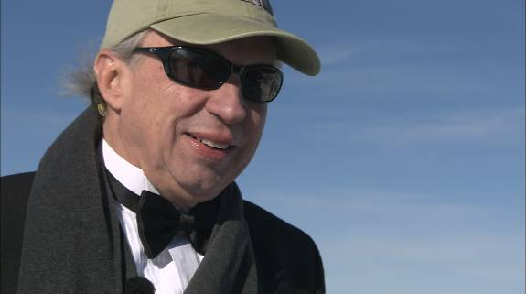
Modern explorer Richard Bangs dons a tuxedo and black tie for a visit to the Schilthorn, the location of a James Bond film shot in the Swiss Alps. In Adventures with Purpose, “Quest for the Sublime,” Bangs delves into how Switzerland’s alpine beauty helped inspire today’s ecotourism movement. Bangs’ quest is to discover the roots of adventure travel and to search for what philosophers and poets of earlier times called “the sublime.” Bangs is host and co-executive producer for Adventures with Purpose, a series of one-hour documentary specials from American Public Television. Richard, a renowned modern explorer, has published more than 1000 magazine articles, 18 books, a score of documentaries and several CD-ROMs; and has lectured at the Smithsonian, the National Geographic Society, the Explorers Club and many other notable venues. He writes a semi-regular feature with the New York Times and was recently honored with a 2007 Lowell Thomas Award for travel journalism.

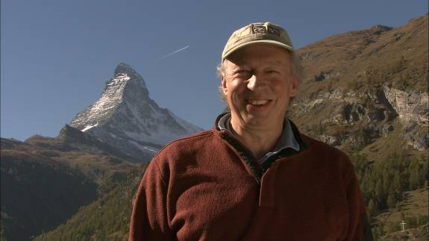
Renowned writer and adventurer Richard Bangs on his way to the famous—and infamous—Matterhorn in the Swiss Alps. In “Switzerland: Quest for the Sublime” a new, one-hour American Public Television special, Bangs is in search of the origins of adventure tourism and how the experiences of past artists and writers in the Swiss Alps have transformed our notion of travel. Leader of 35 first descents of rivers around the globe, a mountain climber and renowned author, Richard brings a lifetime of experience to Adventures with Purpose. Switzerland: Quest for the Sublime” is the latest episode in this series of on-hour documentary specials produced by Small World Productions of Seattle and co-produced by KCTS/Seattle and Richard Bangs Productions of Marina del Rey, California. APT of Boston distributes this award-winning documentary series to more than 250 public stations nationally.

These and additional photos may be downloaded from the press section of www.AdventuresWithPurpose.tv
Richard Bangs’ Adventures with Purpose are sponsored in part by Exofficio Travel Apparel—www.Exofficio.com.

Small World Productions
140 Lakeside Ave. Suite 200
Seattle, WA 98122

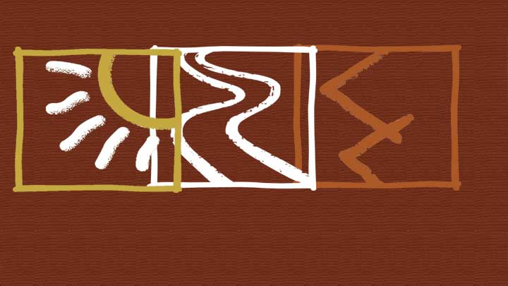

Switzerland: Quest for the Sublime



